Serial and Parallel Communication Interface
The interface to a peripheral from an I/O module must be tailored to the nature and operation of the peripheral. One major characteristic of the interface is whether it is serial or parallel as shown in the figure below.
In a parallel interface, there are multiple lines connecting the I/O module and the peripheral, and multiple bits are transferred simultaneously, just as all of the bits of a word are transferred simultaneously over the data bus.
A parallel interface has traditionally been used for higher-speed peripherals, such as tape and disk, while the serial interface has traditionally been used for printers and terminals. With a new generation of high-speed serial interfaces, parallel interfaces are becoming much less common.

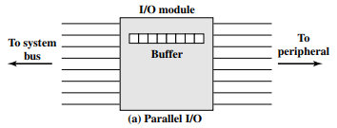

In a serial interface, there is only one line used to transmit data, and bits must be transmitted one at a time. A parallel interface has traditionally been used.
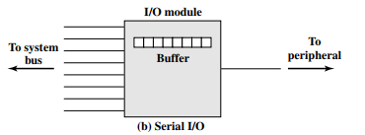

In either case, the I/O module must engage in a dialogue with the peripheral. In general terms, the dialogue for a write operation is as follows:
1. The I/O module sends a control signal requesting permission to send data.
2. The peripheral acknowledges the request.
3. The I/O module transfers data (one word or a block depending on the peripheral).
4. The peripheral acknowledges receipt of the data.

A read operation proceeds similarly.
Key to the operation of an I/O module is an internal buffer that can store data being passed between the peripheral and the rest of the system. This buffer allows the I/O module to compensate for the differences in speed between the system bus and its external lines.

